**Background**

Rio das Pedras is the third largest informal community in Rio de Janeiro, Brazil. Rio das Pedras is home to approximately 63,500 residents. Aggravated by seasonal flooding, hectic vehicle traffic, continuous construction, soil instability, and improvised waste disposal facilities, the limited access to municipal services and transportation likely predispose residents to injury and poor health. However, there is limited data that can accurately characterize the health of residents of Rio das Pedras, and fewer data that can point out areas of improvement. As a result, there is little evidence to guide infrastructure investment or other initiatives to protect the health of residents. To fill this gap, the [Built Environment and Health Research Group at Columbia University (BEH)](http://beh.columbia.edu/) is undertaking a [Community Needs Assessment (Community Health Diagnosis) for the Rio das Pedras area.](http://beh.columbia.edu/2014/07/25/rio-das-pedras-community-needs-assessment/)

Led by [Dr. Gina Lovasi](http://www.mailman.columbia.edu/our-faculty/profile?uni=gl2225) and sponsored by [Medtronic Philanthropy](http://philanthropy.medtronic.com/), our research project has brought together an interdisciplinary group of experts to perform this initial community needs assessment in Rio das Pedras. In addition to creating a health profile for the Rio das Pedras community, this project will inform future large scale data collection on health, mobility, and the microbiome in informal communities, which globally, house more than one billion people.

**Rio Das Pedras, Rio de Janiero, Brazil**

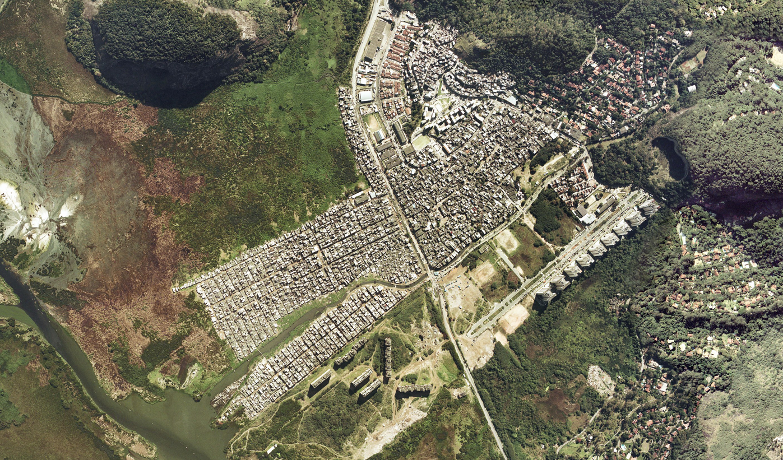 *Source: Instituto Brasileiro de Geografia e Estatística*

**Discovering Fulcrum**

The initial phases of the project involved planning out participant recruitment and data collection via interviews, collection of water and saliva samples, and GPS based mobility monitoring, to be followed by linkage to data on neighborhood environmental conditions in Rio das Pedras. Our usual approach to describing neighborhood built, social and environmental conditions is to use GIS tools and governmental administrative data or commercially sourced data, however such data are not available for Rio das Pedras. Another approach we take to gather data on neighborhood conditions is to conduct [Virtual Street Audits (also called Systematic Social Observation) using Google Street View and our CANVAS tool](http://beh.columbia.edu/2015/01/05/new-research-using-google-street-view-to-conduct-neighborhood-virtual-audits/). Unfortunately, Google Street View is not available for most streets and alleyways in Rio das Pedras. It quickly became clear that we would need to conduct our own field studies to collect data and photos to support our understanding and documentation of the built environment. It was also clear that we needed a tool to collect neighborhood audit data, to organize field notes, a way to geotag photos and way to provide our field team with maps to navigate the neighborhoods in a community that lacked formal street names and house numbering systems.

[*"Fulcrum is a mobile data collection platform that allows users to build, deploy, & collect data with their own customized apps - Available on iOS & Android*](http://fulcrumapp.com/)*." – Fulcrum*

[BEH Geographer Danny Sheehan](http://nygeog.github.io/) came across a [CartoDB blogpost about using Fulcrum](http://docs.cartodb.com/tutorials/data_collection_fulcrum.html) and realized that [Fulcrum](http://fulcrumapp.com/) might provide a single digital solution for our field research needs. The BEH group developed a custom form to help collect data on neighborhood conditions and health using the Fulcrum App interface. This tool enabled the team to systematically collect field data, in-person without using paper, pen and clipboards.

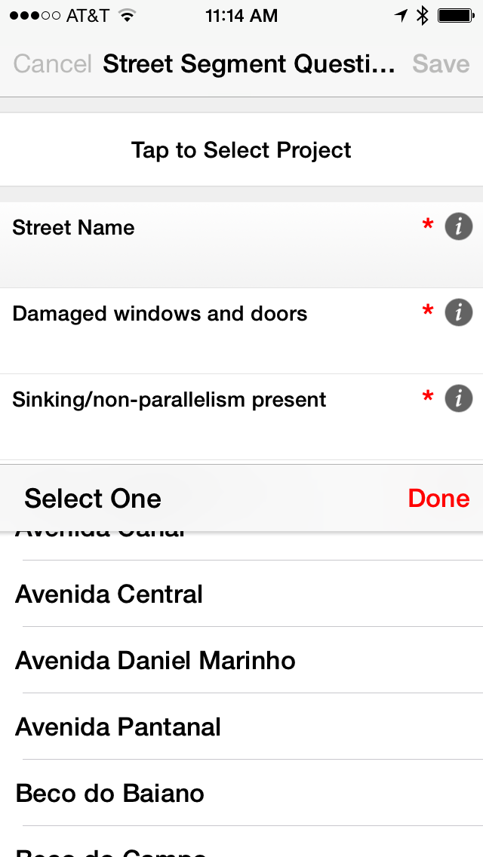

*BEH Systematic Social Observation form on the Fulcrum App for iPhone.*

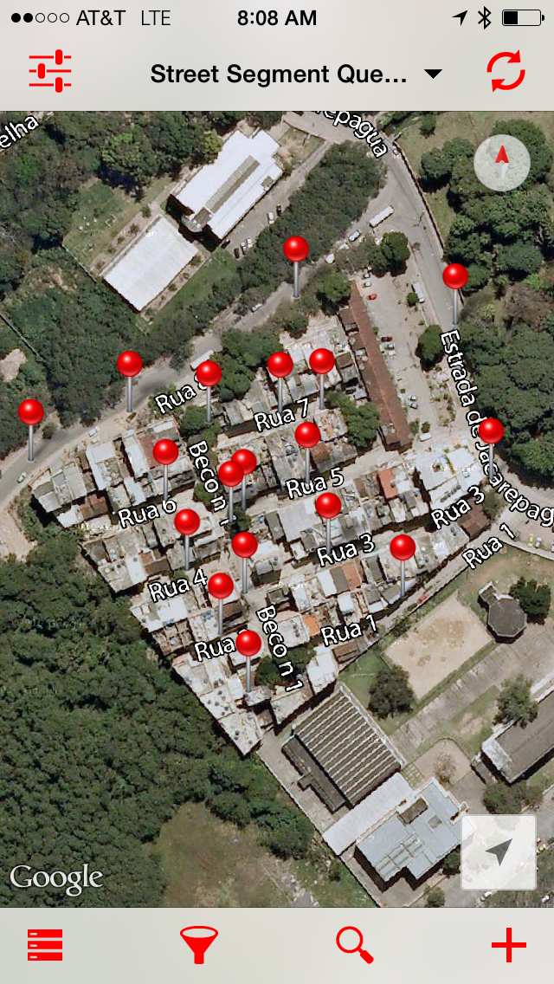

*BEH Systematic Social Observation map on the Fulcrum App for iPhone.*

We piloted the test app for data collection in March 2015. Based on our experience from March, we were able to create a new modified Fulcrum App and also add our own [Map Layers](http://fulcrumapp.com/help/adding-layers/). The team returned to the field again early this May for a more exhaustive and complete round of data collection.

**Notes from the field**

Project Coordinator, Garazi Zulaika:

*"Fulcrum greatly facilitated data collection in the field. Fulcrum's fast synchronization allowed us to communicate in real time and field test our data collection questions with collaborators in different countries. Fulcrum’s ability to store multiple entry points and photos allowed us to collect data throughout the entire day without accessing internet in the field. Another tool that was extremely useful was Fulcrum's ability to pan away from the location set by the device’s GPS. Given our data collection is ongoing in a densely populated informal community with informal construction methods that contribute to poor satellite reception, the ability to change the location of the recorded coordinates by a block or a street, when GPS was not assigning the proper location, improved the accuracy of the data being collected. We found that certain mobile devices had more accurate GPS location while older devices had a harder time correctly identifying the user’s location. The user-friendly platform allowed our research team to tailor the questions to our needs, incorporating context specific questions, modifying the answer categories, adding and deleting items, and going back and editing the responses even after the entry had been completed. The Fulcrum App did not force us to answer questions in order which allowed us to enter form items as we came across them while moving through the informal community. Fulcrum’s flexibility was extremely valuable and allowed us to collect data extremely efficiently and quickly. I look forward to using it again in the field!"*

**Geotagged images from the field**

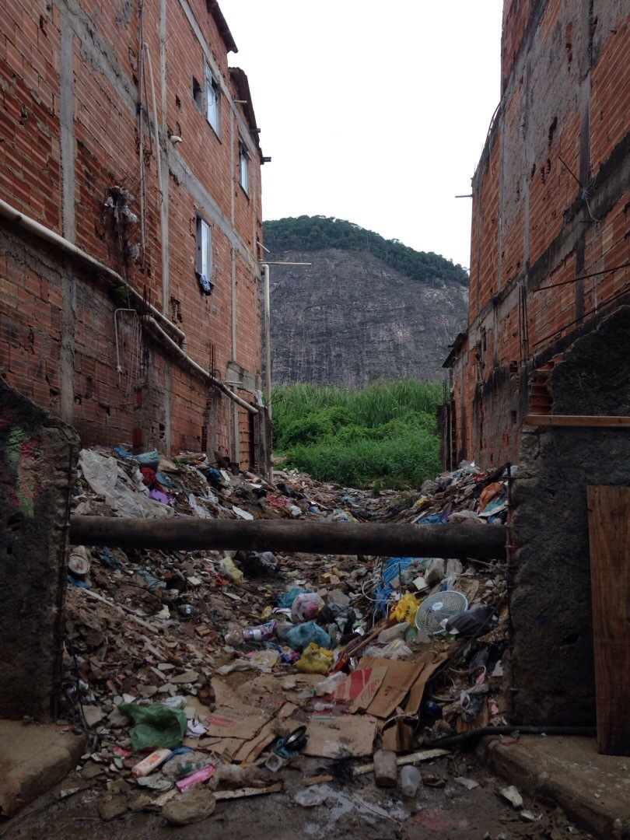

*Sewer pipes in Rio das Pedras geotagged photo from the Fulcrum app.*

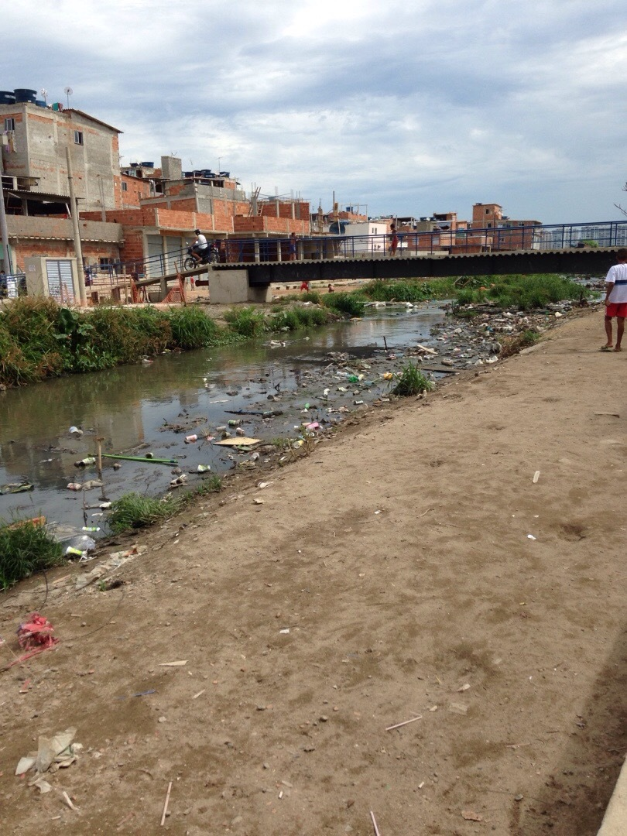

*Avenida Canal in Rio das Pedras geotagged photo via the Fulcrum app.*

**Parting note**

Working with the Fulcrum App and getting support from the Fulcrum team has greatly enhanced our data collection capabilities. We hope to provide a future blogpost as follow-up to our second field data collection effort.